**HX8001 - PROFESSIONAL READINESS FOR INNOVATION, EMPLOYABILITY AND ENTREPRENEURSHIP**

**SMART FASHION RECOMMENDER APPLICATION**

**A PROJECT REPORT**

***Submitted by***

**GOKUL S**

**JESU DENISON K**

**JOHN PRAKASH I**

**JOHN STEPHEN J**

***In partial fulfillment for the award of the degree***

***of***

**BACHELOR OF ENGINEERING**

***In***

**COMPUTER SCIENCE AND ENGINEERING**

**JAYARAJ ANNAPACKIAM CSI COLLEGE OF ENGINEERING**

**COLLEGE, NAZARETH**

**ANNA UNIVERSITY : CHENNAI 600 025**

**APRIL-MAY 2022**

# ABSTRACT

Fashion is perceived as a meaningful way of self-expressing that people use for different purposes. It seems to be an integral part of every person in modern societies, from everyday life to exceptional events and occasions. Fashionable products are highly demanded, and consequently, fashion is perceived as a desirable and profitable industry. Although this massive demand for fashion products provides an excellent opportunity for companies to invest in fashion-related sectors, it also faces different challenges in answering their customer needs. In recent years, the textile and fashion industries have witnessed an enormous amount of growth in fast fashion. On e-commerce platforms, where numerous choices are available, an efficient recommendation system is required to sort, order, and efficiently convey relevant product content or information to users. Smart Fashion Recommender Application have attracted a huge amount of attention from fast fashion retailers as they provide a personalized shopping experience to consumers. Smart Fashion Recommender Application have been introduced to address these needs.

# TABLE OF CONTENT

|  |  |  |
| --- | --- | --- |
| **CHAPTER** | **CONTENTS** | **PAGE NO** |
| **1** | **INTRODUCTION**   * 1. 1.1 PROJECT OVERVIEW   1.2 PURPOSE | **05** |
| **2** | **LITERATURE SURVEY**   * 1. 2.1 EXISTING PROBLEM   2. 2.2 REFERENCE   3. 2.3 PROBLEM STATEMENT DEFINITION | **06** |
| **3** | **IDEATION & PROPOSED SOLUTION**   * 1. 3.1 EMPATHY MAP CANVAS   2. 3.2 IDEATION & BRAINSTROMING   3. 3.3 PROPOSED SOLUTION   4. 3.4 PROBLEM SOLUTION FIT | **12** |
| **4** | **REQUIREMENT ANALYSIS**   * 1. 4.1 FUNCTIONAL REQUIREMENT   2. 4.2 NON-FUNCTIONAL REQUIREMENTS | **17** |
| **5** | **PROJECT DESIGN**   * 1. 5.1 DATA FLOW DIAGRAMS   2. 5.2 SOLUTION & TECHNICAL ARCHITECTURE   5.3 USER STORIES | **19** |
| **6** | **PROJECT PLANNING & SCHEDULING**   * 1. 6.1 SPRINT PLANNING & ESTIMATION   2. 6.2 SPRINT DELIVERY SCHEDULE   3. 6.3 REPORTS FROM JIRA | **22** |

|  |  |  |
| --- | --- | --- |
| **7** | **CODING & SOLUTIONING**  7.1 FEATURE 1   * 1. 7.2 FEATURE 2   7.3 DATABASE SCHEMA | **27** |
| **8** | **TESTING**   * 1. 8.1 TEST CASES   2. 8.2 USER ACCEPTANCE TESTING | **29** |
| **9** | **ADVANTAGES & DISADVANTAGES** | **30** |
| **10** | **CONCLUSION** | **31** |
| **11** | **FUTURE SCOPE** | **32** |
| **12** | **APPENDIX**  12.1 SOURCE CODE  12.2 GITHUB & PROJECT DEMO LINK | **33** |

**CHAPTER-1**

**INTRODUCTION**

## 1.1 PROJECT OVERVIEW

The Fashion industry is one of the larger industries around the world. One of the things that has remained constant throughout human civilization is humans covering their bodies with a piece of cloth. Initially, this cloth was worn as protection from the harsh climates of those ages. Later on, as we humans learned to fend for ourselves from the unforgiving climates, the cloth started to serve a different purpose. Fashion these days showcases the individuality of the person. There are many things that can be said about a person based on their fashion sense.

## 1.2 PURPOSE

There is currently no existing system that is capable of recommending clothes based on the occasion. Different occasions call for different clothing. Moreover, a lot of fashion is based on the color combinations of outfits. A person with no or little fashion sense will have a hard time to decide on clothes that leave a lasting impression. The proposed Fashion Recommendation System is intended to be used by individual users in order to store images of the clothes that they own in what is called a digital wardrobe and also to get recommendations by the system on what clothes to wear for a given occasion. The main aim of the project is to recommend the most appropriate clothes for a given occasion based on the clothes existing in the user’s wardrobe to relieve the user of the burden of making decisions about what clothing to wear. Such a system should be capable of helping someone who has no fashion sense to wear clothes that leave a good impression on others. The system should be such that it is easily accessible and easy to take advantage of the various features that it provides. One of the features should be the ability to store images that the user uploads into a wardrobe. A wardrobe is a very useful entity that the user can use to view and manage the images of clothes that they have uploaded. This feature can also be used by the recommendation algorithm to recommend the clothes. Another feature is the classification of the type and color of the clothing that is uploaded by the user. The system should be capable of handling the 4 basic clothing types: Shirt, T-Shirt, Pants and Shoes.

**CHAPTER-2**

# LITERATURE SURVEY

## 2.1 EXISTING PROBLEM:

In existing system only simple web application and their rating has been implemented in existing system, An ecommerce product recommendation engine is a piece of technology that displays recommended products to shoppers throughout your store. It uses machine learning to get smarter and show increasingly relevant products to shoppers based on their interests and previous browsing behavior

**2.2 REFERENCE**

**Paper 1: A Review of Modern Fashion Recommender Systems**

A Review of Modern Fashion Recommender Systems**,** Yashar Deldjoo, Fatemeh Nazary,

Amau Ramisa, Julian McAuley , Giovanni Pellegrini , Alejandro Bellogin, and Tommaso Di Noia,

December2021, ACMComput.Surv.37,4.Articlel11(December2021).

The textile and apparel industries have grown tremendously over the last years. Customers no longer have to visit many stores, stand in long queues, or try on garments in dressing rooms as millions of products are now available in online catalogs. However, given the plethora of options available, an effective recommendation system is necessary to properly sort, order, and communicate relevant product material or information to users. Effective fashion RS can have a noticeable impact on billions of customers’ shopping experiences and increase sales and revenues on the provider-side. The goal of this survey is to provide a review of recommender systems that operate in the specific vertical domain of garment and fashion products. We have identified the most pressing challenges in fashion RS research and created a taxonomy that categorizes the literature according to the objective they are trying to accomplish and type of side-information (users, items, context). We have also identified the most important evaluation goals and perspectives and the most commonly used datasets and evaluation metrics.

# Paper 2: Design of Garment Style Recommendation System Based on Interactive Genetic Algorithm

Design of Garment Style Recommendation System Based on Interactive Genetic Algorithm,

Yan Zhao, 24 March 2022, Research Article | Open Access, Volume2022|ArticleID9132165.

Recommender systems provide users with product information and suggestions, which has gradually become an important research tool in e-commerce IT technology, which has attracted a lot of attention of researchers. Collaborative filtering recommendation technology has been the most successful recommendation technology so far, but there are two major problems—recommendation quality and scalability. At present, research at home and abroad mainly focuses on recommendation quality, and there is less discussion on scalability. -e scalability problem is that as the size of the system increases, the response time of the system increases to a point where users cannot afford it. Existing solutions often result in a significant drop in recommendation quality while reducing recommendation response time. In this paper, the clustering analysis subsystem based on the genetic algorithm is innovatively introduced into the traditional collaborative filtering recommendation system, and its design and implementation are given. In addition, when obtaining the nearest neighbors, only the clustered users of the target user are searched, making it a collaborative filtering recommender system based on genetic clustering. -e experimental results show that the response time of the traditional collaborative filtering recommender system increases linearly with the increase in the number of users while the response time of the collaborative filtering recommender system based on genetic clustering remains unchanged with the increase in the number of users.

# Paper 3: Fashion Recommendation System Model and Methods

# 

# Fashion Recommendation System Model and Methods Samit Chakraborty , Md.

# Saiful Hoque , Naimur Rahman Jeem, Manik Chandra Biswas, Deepayan Bardhan, Edgar

# Lobaton, 26 July 2021, Informatics 2021, 8(3), 49.

In recent years, the textile and fashion industries have witnessed an enormous amount of growth in fast fashion. On e-commerce platforms, where numerous choices are available, an efficient recommendation system is required to sort, order, and efficiently convey relevant product content or information to users. Image-based fashion recommendation systems (FRSs) have attracted a huge amount of attention from fast fashion retailers as they provide a personalized shopping experience to consumers. With the technological advancements, this branch of artificial intelligence exhibits a tremendous amount of potential in image processing, parsing, classification, and segmentation. Despite its huge potential, the number of academic articles on this topic is limited. The available studies do not provide a rigorous review of fashion recommendation systems and the corresponding filtering techniques. To the best of the authors’ knowledge, this is the first scholarly article to review the state-of-the-art fashion recommendation systems and the corresponding filtering techniques. In addition, this review also explores various potential models that could be implemented to develop fashion recommendation systems in the future. This paper will help researchers, academics, and practitioners who are interested in machine learning, computer vision, and fashion retailing to understand the characteristics of the different fashion recommendation systems.

# Paper 4: A Review on Outfit Fashion recommendation System

# A Review on Outfit Fashion recommendation System, Bhagyshree Pravin

# Bhure, Pratiksha Tulshiram Bansod, Monali Shivram Amgaokar, Savita Pralhad Lodiwale,

# Anjali pravin, ashish Mohod, 18 May 2021.

|  |
| --- |
| With the quick rise in living standards, people's shopping passion grew, and their desire for clothing grew as well. A growing number of people are interested in fashion these days. However, when confronted with a large number of garments, consumers are forced to try them on multiple times, which takes time and energy. As a result of the suggested Fashion Recommendation System, a variety of online fashion businesses and web applications allow buyers to view collages of stylish items that look nice together. Clients and sellers benefit from such recommendations. On the one hand, customers can make smarter shopping decisions and discover new articles of clothes that complement one other. Complex outfit recommendations, on the other hand, assist vendors in selling more products, which has an impact on their business. Fashion Net is made up of two parts: a feature network for extracting features and a matching network for calculating compatibility. A deep convolutional network is used to achieve the former. For the latter, a multi-layer completely connected network topology is used. For Fashion Net, you must create and compare three different architectures. To achieve individualised recommendations, a two-stage training technique was created. |

# Paper 5: A Review on Clothes Matching and Recommendation Systems based on user Attributes

# A Review on Clothes Matching and Recommendation Systems based on user Attributes, Atharv Pandit, Kunal Goe1, Manav Jain, Neha Katre,03-09-2020, IJERT.

Dressing appropriately is very important when going out in the real world. Wearing clothes properly that show some level of style and wearing them such that they adhere to the norms of social standards uplifts the confidence of the person and creates a very good impression. The study focuses on helping the user to find optimized matching pair of clothes taking into account intricate details like style, patterns, colors, textures, etc. also keeping in mind users attributes like age, skin tone, favorite color etc. It aims to help the user choose clothes that are fashionable and organize their closet. It tries to help the user to wear clothes that are suitable to occasions and helps user to buy clothes that would suit their style. In this paper, an in depth study is performed of various systems that are developed for the various features that must be kept in mind for making a robust system that finds matching clothes of the user as well as makes recommendations. Systems developed to make recommendations of clothes using various approaches have been studied and their merits and demerits high-lighted. Systems that are used for clothes detection have also been studied to make the system user- friendly while the user provides input.

## 2.3 PROBLEM STATEMENT DEFINITION

The personal information collected by recommenders raises the risk of unwanted exposure of that information. Also, malicious users can bias or sabotage the recommendations that are provided to other users.In recent years, the textile and fashion industries have witnessed an enormous amount of growth in fast fashion. On e-commerce platforms, where numerous choices are available, an efficient recommendation system is required to sort, order, and efficiently convey relevant product content or information to users.

* The problem of the work is to design static web applications deployments with customer deployment
* Lack of interaction between application and user
* User need to navigate across multiple pages to choose right product
* Confusion in choosing product
* Lack of sales
* Complex User Interface.
* Lack of proper guidance.

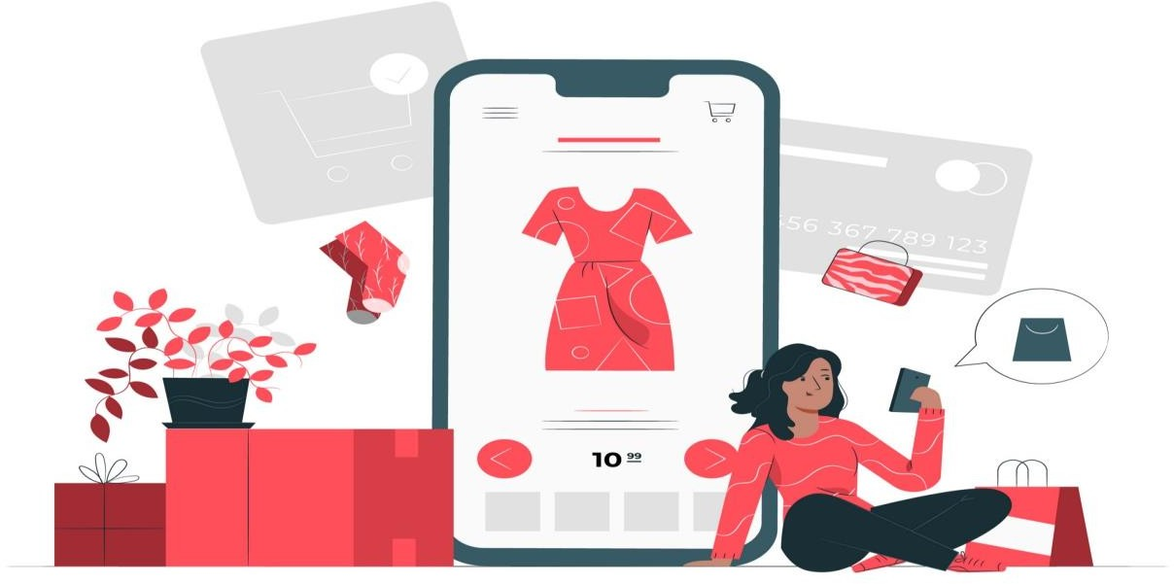

**CHAPTER-3**

# IDEATION & PROPOSED SOLUTION

## 3.1 EMPATHY MAP CANVAS:

An empathy map is a simple, easy-to-digest visual that captures knowledge about a user’s behaviours and attitudes. It is a useful tool to helps teams better understand their users. Creating an effective solution requires understanding the true problem and the person who is experiencing it. The exercise of creating the map helps participants consider things from the user’s perspective along with his or her goals and challenges. An empathy map is a collaborative tool teams can use to gain a deeper insight into their customers.

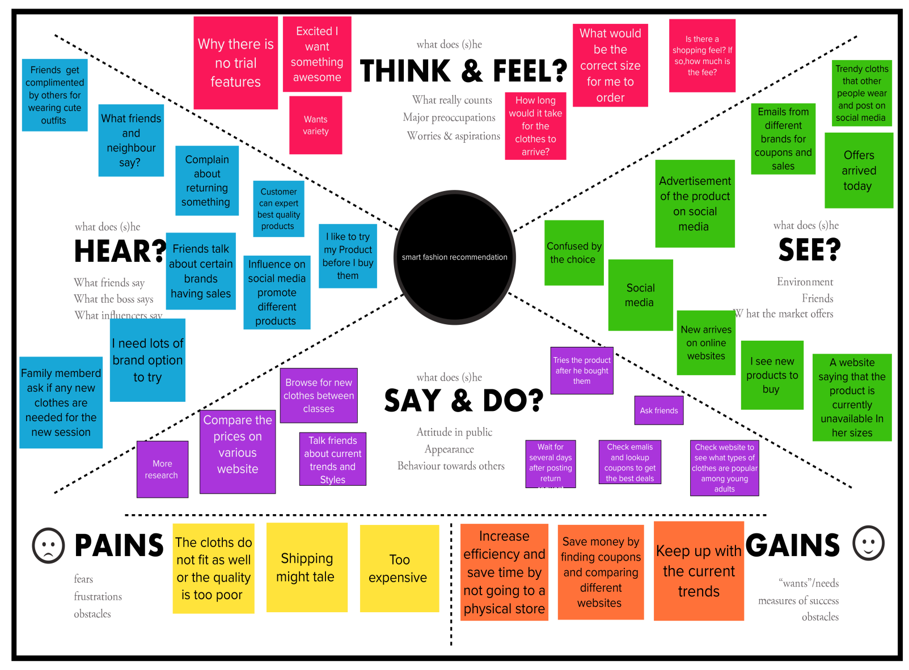

Reference:

<https://app.mural.co/invitation/mural/fashionrecommderapplication7598/1664037379529>

[?sender=ueb3338e9f75abcd9a7456911&key=5b4777b7-745a-4236-a581-ef8455d48eaa](https://app.mural.co/invitation/mural/fashionrecommderapplication7598/1664037379529)

## 3.2 IDEATION & BRAINSTROMING:

A group problem-solving technique that involves the spontaneous contribution of ideas from all members of the group. The mulling over of ideas by one or more individuals in an attempt to devise or find a solution to a problem.

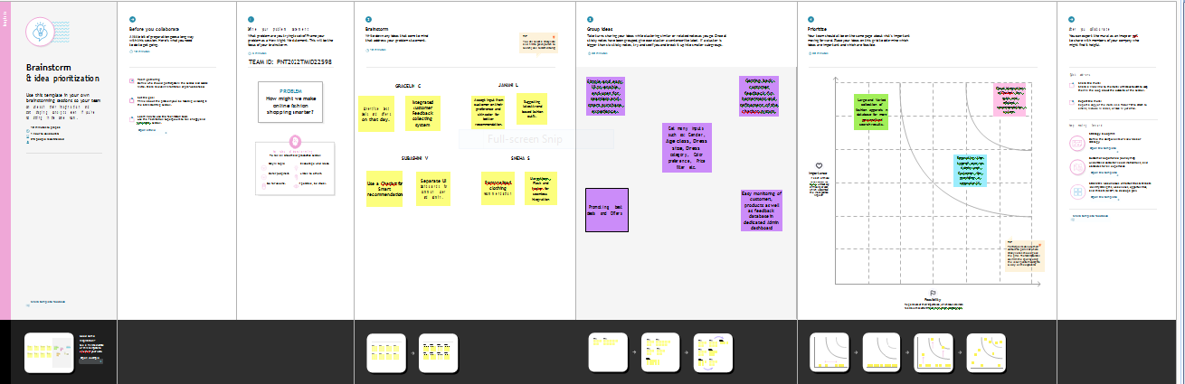

## 3.3 PROPOSED SOLUTION:

|  |  |  |
| --- | --- | --- |
| **S. No.** | **Parameter** | **Description** |
| 1. | Problem Statement | How can we make online fashion shopping even smarter ?  Even though online shopping is convenient , the main problem is that a shopping cart cannot say “This dress looks like it was made especially for you ,mam” or “ May I suggest a top that  perfectly matches with the pant ?” |
| 2. | Idea / Solution description | * **Chatbot** helps the customer in selecting an Outfit * Customer can easily ask for what they want and it filters the various collection to suggest the products fitting their style. * The Bot will assist the customers till   the purchase is done. |
| 3. | Novelty / Uniqueness | * With the help of IBM Cloud Object Storage, we are going to store and manage large amount of data which is highly scalable and secure. * Give recommendation based on customer interest. * The chatbot indeed keeps you engaged   and perfectly fits the designer’s goal of “Going directly to the consumer”. |
| 4. | Social Impact / Customer Satisfaction | * Fashion recommending chatbots , the automated and smart contextual messaging system act as a personal stylists. * Integrated customer Feedback collecting system. * Advertise best deals and offers on that   day. |

|  |  |  |
| --- | --- | --- |
| 5. | Business Model (Revenue Model) | * Simple and easy UI to enable end-user for seamless and smart purchase experience. * Get many inputs such as: Gender, Age, Dress size, Dress category, Color preference, Price filter etc.. for better recommendation. * Easy monitoring of customers,   products as well as feedback database in dedicated Admin dashboard. |
| 6. | Scalability of the Solution | * Large and Varied collection of fashion apparels in database for more personalised search results. * Cloud integration of Chatbot for quick and efficient recommendation system. * Chatbots may be seen as a user interface for fashion applications by providing recommendations, exploring and searching huge catalogues , complementing virtual fitting room features and delivering customer   services. |

**3.4 PROBLEM SOLUTION FIT**

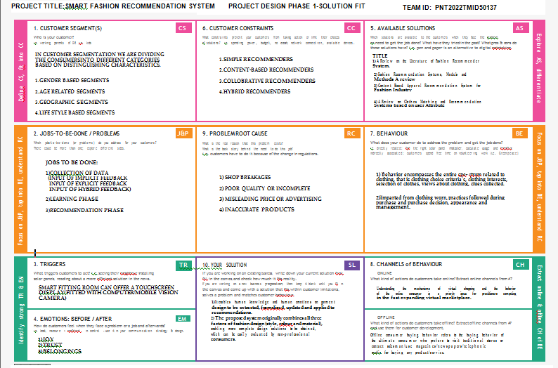

**CHAPTER-4**

# REQUIREMENT ANALYSIS

## 

## 4.1 FUNCTIONAL REQUIREMENT:

Following are the functional requirements of the proposed solution.

|  |  |  |
| --- | --- | --- |
| **FR No.** | **Functional Requirement (Epic)** | **Sub Requirement (Story / Sub-Task)** |
| FR-1 | User Registration | Registration through Form |
| FR-2 | User Interaction | I  nteract through the Chat Bot |
| FR-3 | Buying Products | Through the chat Bot Recommendation |
| FR-4 | Track Products | Ask the Chat Bot to Track my Orders |
| FR-5 | Return Products | Through the chat Bot |
| FR_6 | New Collections | Recommended from chat Bot |

## 4.2 NON-FUNCTIONAL REQUIREMENTS:

Following are the non-functional requirements of the proposed solution.

|  |  |  |
| --- | --- | --- |
| **FR No.** | **Non-Functional Requirement** | **Description** |
| NFR-1 | **Usability** | Using Android or IOS or windows applications. |
| NFR-2 | **Security** | The user data is stored securely in IBM cloud. |
| NFR-3 | **Reliability** | The Quality of the services are trusted. |
| NFR-4 | **Performance** | I ts Provide smooth user experience. |
| NFR-5 | **Availability** | The services are available for 24/7. |
| NFR-6 | **Scalability** | Its easy to scalable size of users and products. |

**CHAPTER-5**

## PROJECT DESIGN

**5.1 DATA FLOW DIAGRAMS:**

A Data Flow Diagram (DFD) is a traditional visual representation of the information flows within a system. A neat and clear DFD can depict the right amount of the system requirement graphically. It shows how data enters and leaves the system, what changes the information, and where data is stored.

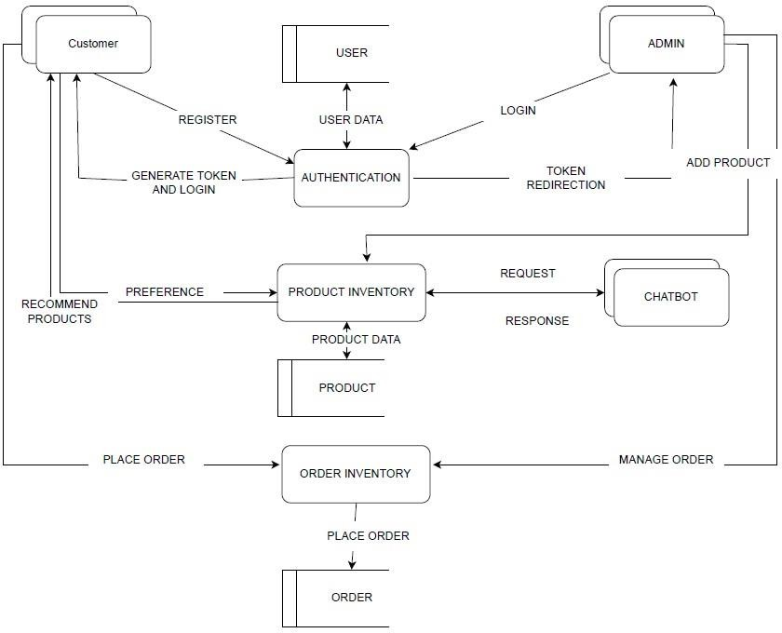

## 5.2 SOLUTION & TECHNICAL ARCHITECTURE:

We have developed a new innovative solution through which you can directly do your online shopping based on your choice without any search. It can be done by using the chatbot. In this project you will be working on two modules:

* Admin
* User

Instead of searching for products in the search bar and navigating to individual products to find required preferences, this project leverages the use of chatbots to gather all required preferences and recommend products to the user. The solution is implemented in such a way as to improve the interactivity between customers and applications. The chatbot sends messages periodically to notify offers and preferences. For security concerns, this application uses a token to authenticate and authorize users securely. The token has encoded user id and role. Based on the encoded information, access to the resources is restricted to specific users.

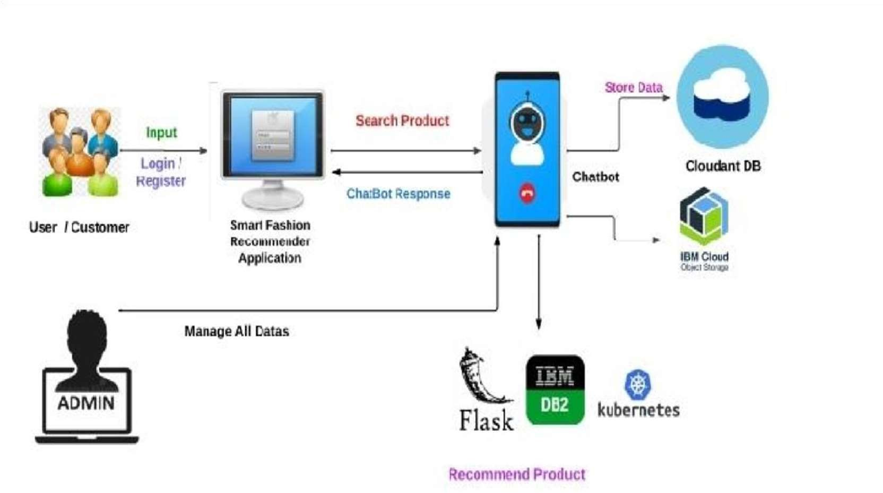

## 5.3 USER STORIES :

|  |  |  |  |  |  |  |
| --- | --- | --- | --- | --- | --- | --- |
| **User Type** | **Functional**  **Requirement (Epic)** | **User Story Number** | **User Story / Task** | **Acceptance criteria** | **Priority** | **Release** |
| Customer (Mobile user) | Registration | USN-1 | As a user, I can register for the application by  entering my email, password, and confirming my password. | I can access my account / dashboard | High | Sprint-1 |
|  |  | USN-2 | As a user, I will receive confirmation email  once I have registered for the application | I can receive confirmation  email & click confirm | High | Sprint-1 |
|  |  | USN-3 | As a user, I can register for the application through Facebook | I can register & access the dashboard with Facebook  Login | Low | Sprint-2 |
|  |  | USN-4 | As a user, I can register for the application  through Gmail |  | Medium | Sprint-1 |
|  | Login | USN-5 | As a user, I can log into the application by  entering email & password | I can access and make  purchases. | \High | Sprint-1 |
|  | Dashboard |  |  |  |  |  |
| Customer (Web user) | Registration | USN-1 | As a user, I can register for the application by entering my email, password, and confirming my password. | I can access my account / dashboard | High | Sprint-1 |
|  |  | USN-2 | As a user, I will receive confirmation email  once I have registered for the application | I can receive confirmation  email & click confirm | High | Sprint-1 |
|  |  | USN-3 | As a user, I can register for the application through Facebook | I can register & access the dashboard with Facebook  Login | Low | Sprint-2 |
|  |  | USN-4 | As a user, I can register for the application  through Gmail |  | Medium | Sprint-1 |
|  |  | USN-5 | As a user, I can log into the application by  entering email & password | I can access and make  purchases. | High | Sprint-1 |
| Administrator | Login | USN-1 | I enter my mail and password on  organisation’s approval | I can approve products  and purchases | High | Sprint-1  Administrator |

**6.PROJECT PLANNING & SCHEDULE**

## 6.1 SPRINT PLANNING & ESTIMATION:

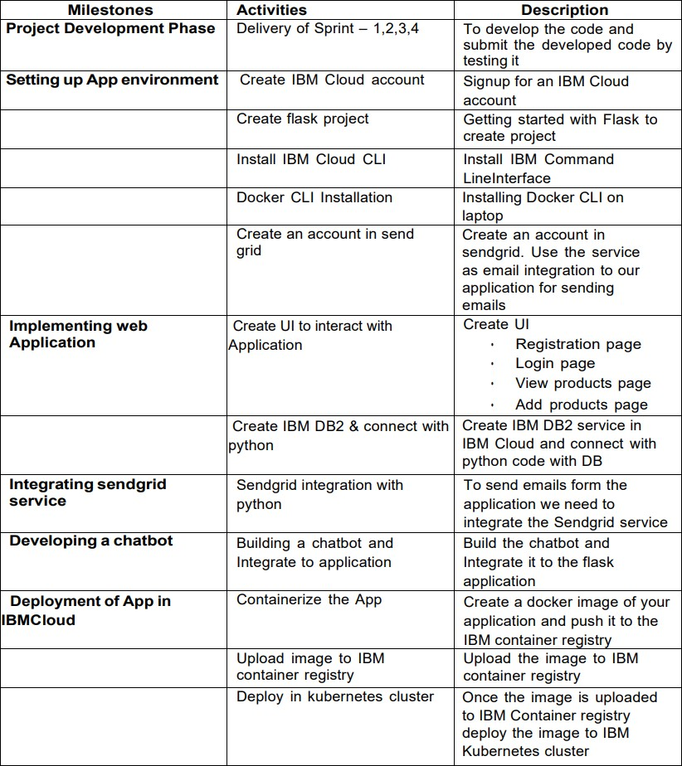

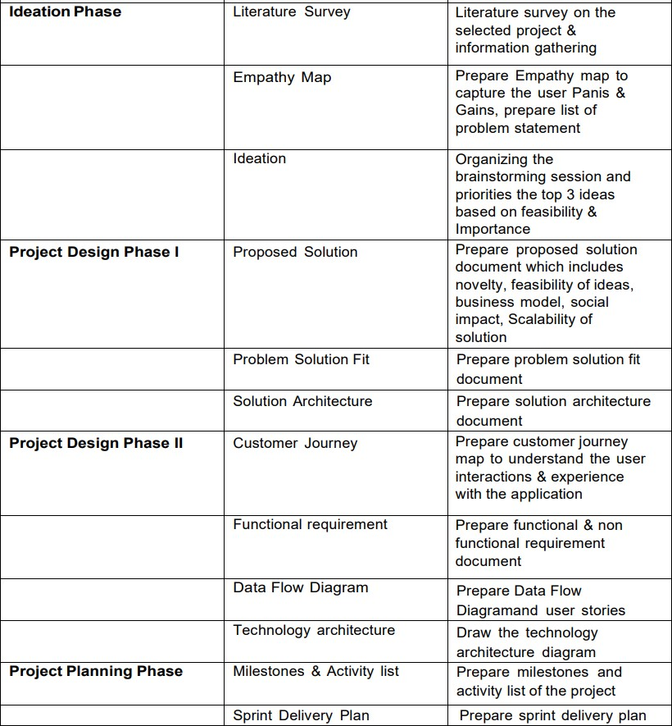

* 1. **6.2 SPRINT DELIVERY SCHEDULE:**

|  |  |  |  |  |  |  |
| --- | --- | --- | --- | --- | --- | --- |
| Sprint | Functional  Requirement (Epic) | User Story Number | User Story / Task | Story points | Priority | Team Members |
| Sprint-1 | Setting up App environment | USN-1 | As a user, I can register in ICTA  Academy and create IBM cloud account. | 2 | High | Gokul S  Jesu Denison K |
| Sprint-1 |  | USN-2 | As a user, I will create a flask project | 1 | Low | John Prakash I  John Stephen J |
| Sprint-1 |  | USN-3 | As a user, I will install IBM Cloud CLI | 2 | Medium | Gokul S  Jesu Denison K |
| Sprint-2 | Setting up App environment | USN-4 | As a user, I can install Docker CLI | 1 | Low | John Prakash I  John Stephen J |
| Sprint-2 |  | USN-5 | As a user, I will Create an account in sendgrid | 2 | Medium | Gokul S  Jesu Denison K |

|  |  |  |  |  |  |  |
| --- | --- | --- | --- | --- | --- | --- |
| Sprint-3 | Implementing web application | USN-6 | As a user, I Create UI to interact with the application | 1 | High | John Prakash I  John Stephen J |
| Sprint-3 |  | USN-7 | As a user, I Create IBM DB2 and connect with Python | 3 | High | Gokul S |
| Sprint-3 | Integrating sendgrid service | USN-8 | As a user, I will integrating sendgrid with python code | 2 | High | Jesu Denison K |
| Sprint-3 | Developing a chatbot | USN-9 | As a user, I have to build a chatbot and Integrate to application | 1 | Medium | John Prakash I |
| Sprint-4 | Development of App in IBM Cloud | USN-10 | As a user, I will Containerize the App | 1 | Low | John Stephen J |
| Sprint-4 |  | USN-11 | As a user, I will upload image to IBM Container registry | 2 | Medium | John Stephen J |
| Sprint-4 |  | USN-12 | As a user, I will deploy App in Kebernetes cluster | 3 | High | John Prakash I |
| Sprint-4 | User panel |  | As a user   * Register, Login, Email, Verification * Manual Search * Order placement, Order Details | 3 | High | Gokul S  Jesu Denison K  John Prakash I  John Stephen J |

|  |  |  |  |  |  |  |
| --- | --- | --- | --- | --- | --- | --- |
| Sprint | Total Story Points | Duration | Sprint Start Date | Sprint End Date (Planned) | Story Points Completed (as on Planned End  Date) | Sprint Release Date (Actual) |
| Sprint-1 | 18 | 6 Days | 24 Oct 2022 | 29 Oct 2022 | 24 | 29 Oct 2022 |
| Sprint-2 | 18 | 6 Days | 31 Oct 2022 | 05 Nov 2022 | 24 | 05 Nov 2022 |
| Sprint-3 | 18 | 6 Days | 07 Nov 2022 | 12 Nov 2022 | 24 | 12 Nov 2022 |
| Sprint-4 | 18 | 6 Days | 14 Nov 2022 | 19 Nov 2022 | 24 | 19 Nov 2022 |

## 

# Velocity

Imagine we have a 6-day sprint duration, and the velocity of the team is 18(points per sprint). Let’s calculate the team’s average velocity (AV) per iteration unit (story points per day)

AV = Sprint Duration / Velocity

AV = 24/6 = 4

## 6.3 REPORTS FROM JIRA:

A burn down chart is a graphical representation of work left to do versus time. It is often used in agile software development methodologies such as Scrum. However, burn down charts can be applied to any project containing measurable progress over time.



Setting up App

Environment

Integrating sendgrid

service

Developing

a chatbot

Implementing

web App

Deployment of

app in IBM Cloud

**Oct 24 - 29**

**Week 1**

**CHAPTER-7**

**CODING & SOLUTIONING**

**7.1 FIGURE 1:**

HOME PAGE:

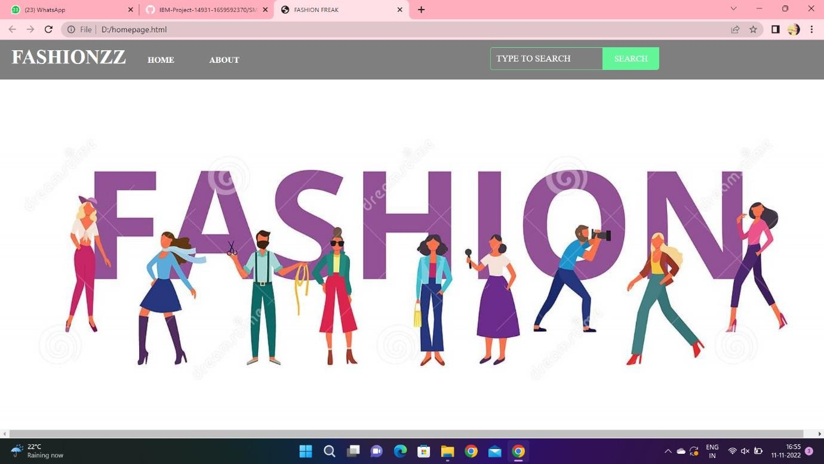

**7.2 FIGURE :**

**FINAL PAGE:**

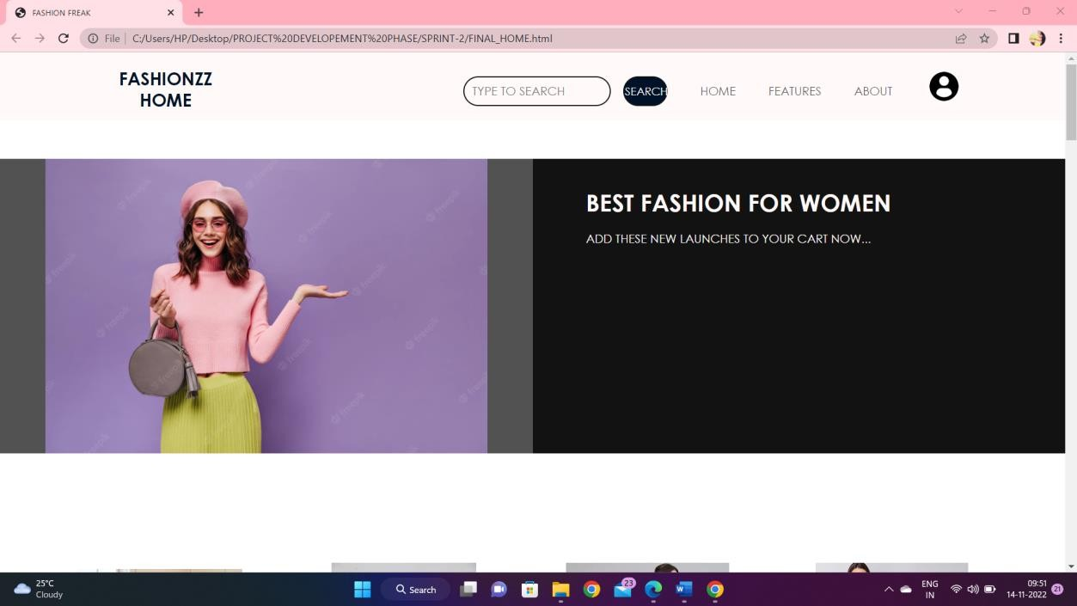

## 7.3 DATABASE SCHEMA:

# CHAPTER-8

# TESTING

**8.1 USER ACCPTENCE TESTING**

## CHAPTER-9

## ADVANTAGES & DISADVANTAGES

**ADVANTAGES:**

* + - Smart fashion recommender application is the user friendly.
    - With the help of chatbot user cand find the products very easily.
    - This application used to discover the product based on the user’s choice , very easily and quickly.
    - It have ability to reduce transaction costs for consumers,and increase revenue for retailers.

## DISADVANTAGES:

* + - * It need active internet connection.
      * Privacy concerns.
      * Too many choices.
      * Cold-start problem.

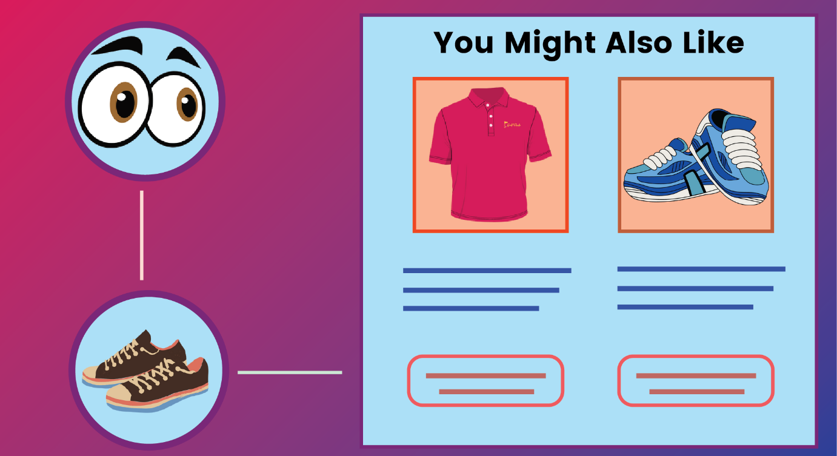

# 

# 

# CHAPTER-10

# CONCLUSION

The Fashion Recommendation System is mainly used to recommend the best possible outfit combinations to a user who has no fashion sense based on their wardrobe . It may not always provide the best possible outfit to wear for an occasion as the system is dependent completely on the clothes present in the user’s wardrobe. Also another reason is that fashion is highly dependent on the time period. However the system does a great job in inculcating a fashion sense among the users and can provide the best recommendations based on the user’s wardrobe. Since the system is implemented as a website, it is very easy for the end users to access as well as use. The scope of this system can be expanded by including the ability to detect the various design and patterns on clothing, and to increase the number of occasions.

**CHAPTER-11**

# FUTURE SCOPE

In the future, to implement this recommendation system to be extended to include male and non-binary fashion items including apparel, footwear, accessories etc. This work can further be enhanced to predict fashion items based on the skin colour and weather conditions.

Future research should concentrate on including time series analysis and accurate categorization of product images based on the variation in colour, trend and clothing style in order to develop an effective recommendation system. The proposed model will follow brand-specific personalization campaigns and hence it will ensure highly curated and tailored. offerings for users. Hence, this research will be highly beneficial for researchers interested in using augmented and virtual reality features to develop recommendation systems.

## 

## CHAPTER-12

## APPENDIX

**12.1 SOURCE CODE:**

## HOMEPAGE.HTML:

<html>

<head>

<title>FASHIONFREAK</title>

</head>

<style>

*{margin:0;

padding:0;

font-family:"TimesNewRoman",Times,serif;

}

.main{

width:100%;

background: linear-gradient(to top,rgba(0,0,0,0.5),rgba(0,0,0,0.5)50%);background-position:center;

background-size: cover;height: 100%;

font-family:"Times NewRoman",Times,serif;

}

.navbar{

width: 100%;height: 75px;margin:auto;

}

.icon{

width: 200px;float: left;height:70px;

}

.logo{

color:#FFFFFF;font-size:35px;

padding-left: 20px;float: left;

padding-top:10px;

}

.menu{

width: 400px;float: left;height:70px;

}

ul{

float: left;display:flex;

justify-content: center;align-items:center;

}

ul li{

list-style: none;margin-left: 62px;margin-top: 27px;font-size: 15px;

}

ul lia{

text-decoration: none;color:#FFFFFF;

font-weight: bold;transition:0.4sease-in-out;

}

ul li a:hover{

color:rgb(98,246,152);

}

.search{

width: 330px;float: left;

margin-left:270px;

}

.srch{

width: 200px;height:40px;

background:transparent;

border: 1px solid rgb(98, 246, 152);margin-top: 13px;

color: #FFFFFF;border- right: none;font-size: 16px;float:left;padding: 10px;

border-bottom-left-radius: 5px;border-top-left-radius:5px;

}

.btn{

width: 100px;height:40px;

background:rgb(98,246,152);

border: 2px solid rgb(98, 246, 152);margin-top: 13px;

color: #FFFFFF;font-size:15px;

border-bottom-right-radius: 5px;border-bottom-right-radius:5px;

}

.btn:focus{outline:none;

}

.srch:focus{outline:none;

}

.content{

width: 1200px;height: auto;margin: auto;color: #800080;position:relative;

}

.content.par

padding-left: 20px;padding-bottom:25px;

letter-spacing: 1.2px;line-height: 30px;

}

.content h1{

font-size: 50px;padding-left: 20px;margin-top: 9%;letter-spacing:2px;

}

.content .cn{width: 160px;height:40px;

background: rgb(98, 246, 152);border: none;

margin-bottom: 10px;margin-left: 20px;font-size: 18px;border-radius: 10px;cursor: pointer;transition:.4sease;

}

.content .cna{

text-decoration: none;color: #FBE7A1;transition:.3sease;

}

background-color:#FBE7A1;

}

.content span{color:rgb(98, 246, 152);font-size: 60px;

}

.form{

width: 250px;height:380px;

background: linear-gradient(to top,hsla(89, 43%, 51%, 0.3));position:absolute;

top: -20px;left:870px;

border-radius: 10px;padding: 25px;

}

.formh2{width:220px;

text-align: center;color:rgb(98, 246, 152);font-size: 22px;

border-radius:

.cn:hover{

10px;margin: 2px;padding: 8px;

}

.form input{width: 240px;height:35px;

background:rgba(0,255,0,0.5);

}

.form input{width: 240px;height:35px;

background:rgba(0,255,0,0.5);

border-bottom: 1px solid rgb(98, 246, 152);border-top: none;

border-right: none;border-left: none;color:#fff;

font-size: 15px;letter-spacing: 1px;margin-top:30px;

}

.form input:focus{outline:none;

}

::placeholder{color:#fff;

}

.btnn{

width: 240px;height:40px;

background: rgb(98, 246, 152);border: none;

margin-top: 30px;font-size: 18px;border-radius: 10px;cursor: pointer;color: #fff;transition:0.4sease;

}

.btnn:hover{background:#fff;

color:rgb(98,246,152);

}

.btnna{

text-decoration: none;color:#000;

font-weight:bold;

}

.form .link{

font-size: 17px;padding-top: 20px;text-align:center;

}

.form .linka{

text-decoration: none;color:rgb(98,246,152);

}

.liw{

padding-top: 15px;padding-bottom: 10px;text-align: center;

}

</style>

<body>

<divclass="main">

<divclass="navbar">

<divclass="icon">

<h2class="logo">FASHIONZZ</h2>

</div>

<divclass="menu">

<ul>

<li><ahref="#">HOME</a></li>

<li><ahref="#">ABOUT</a></li>

</ul>

</div>

<divclass="search">

<inputclass="srch"type="search"name=""placeholder="TYPETOSEARCH">

<ahref="#"><buttonclass="btn">SEARCH</button></a>

</div>

<img src="C:\Users\HP\Downloads\fashion-banner-people-cartoon-characters-flat-vector-illustration-isolated-fashion-banner-people-cartoon-characters-190292392.jpg">

</div>

</div>

</body>

</html>

**FINALHOME.HTML:**

<html>

<head>

<metaname="viewpoint"content="width=device-width,initial-scale=1.0">

<title>FASHIONFREAK</title>

<link rel="stylesheet" href="https://storagedemo-madzh.s3.jp-tok.cloud-object-storage.appdomain.cloud/MadmukFinalhomecss.css">

</head>

<body>

<nav>

<aclass="logo"href="MadFinalhome.html"><h2>FASHIONZZHOME</h2></a>

<ul>

SEARCH">

<li><inputclass="srch"type="search"name=""placeholder="TYPETO

<ahref="#"><buttonclass="btn">SEARCH</button></a></li>

<li><ahref="#">HOME</a></li>

<li><ahref="#">FEATURES</a></li>

<li><ahref="#">ABOUT</a></li>

</ul>

<imgsrc="https://storagedemo-madzh.s3.jp-tok.cloud-object-storage.appdomain.cloud/images/profile.jpeg"class="user-pic"onclick="toggleMenu()">

<divclass="sub-menu-wrap"id="subMenu">

<divclass="sub-menu">

<divclass="user-info">

<imgsrc="https://storagedemo-madzh.s3.jp-tok.cloud-object-storage.appdomain.cloud/images/profile.jpeg">

<h2>NAME</h2>

</div>

<hr>

<ahref="#"class="sub-menu-link">

<imgsrc="https://storagedemo-madzh.s3.jp-tok.cloud-object-storage.appdomain.cloud/images/profile.jpeg">

<p>EDITPROFILE</p>

</a>

<ahref="#"class="sub-menu-link">

<imgsrc="https://storagedemo-madzh.s3.jp-tok.cloud-object-storage.appdomain.cloud/images/settings.jpeg">

<p>SETTING&PRIVACY</p>

</a>

<ahref="#"class="sub-menu-link">

<imgsrc="https://storagedemo-madzh.s3.jp-tok.cloud-object-storage.appdomain.cloud/images/help.jpeg">

<p>HELP</p>

</a>

<ahref="/Login"class="sub-menu-link">

<imgsrc="https://cdn-icons-png.flaticon.com/512/56/56805.png">

<p>LOGOUT</p>

</a>

</div>

</div>

</nav>

<divclass="Banner">

<div class="Bannerimg1"><imgimg class="image" src="https://img.freepik.com/free-photo/joyful-parisian-woman-beret-sunglasses-points-place-text-purple-wall_197531-24604.jpg?w=2000"></div>

<divclass="Adcontent">

<h1><br>BESTFASHIONFORWOMEN</br></h1>

<br>ADDTHESENEWLAUNCHESTOYOURCARTNOW...</br>

</div>

</div>

<divclass="rowstart">

<div class="columnst"><div class="depimg"><img class="image"src="https://cdn0.weddingwire.in/article/2617/original/1280/jpg/107162-wedding-dresses-for-girls-6.jpeg"></div><divclass="Bottom">WEDDING& FESTIVE</div></div>

<div class="columnst"><div class="depimg"><img class="image"src="https://previews.123rf.com/images/vadymvdrobot/vadymvdrobot1801/vadymvdrobot18

0102335/94122785-full-length-image-of-smiling-asian-woman-in-business-clothes-and-eyeglasses-holding-smartphone-while.jpg"></div><div class="Bottom">BACK TODESK</div></div>

<div class="columnst"><div class="depimg"><img class="image"src="https://i.pinimg.com/474x/29/00/fa/2900fa4d1599631766420338e531b2b2.jpg"></div>

<divclass="Bottom">VACAYMOOD</div></div>

<div class="columnst"><div class="depimg"><img class="image"src="https://img.faballey.com/images/Product/DRS02948Z/1.jpg"></div><divclass="Bottom">PARTYALL NIGHT</div></div>

</div>

<divclass="Banner">

<div class="Bannerimg2"><imgimg class="image"src="https://bluejay.com.my/wp-content/uploads/2021/12/Kids-clothes-Hong-Kong-seed.jpg"></div>

<divclass="Adcontent2">

<h1><br>KIDSFASHION</br></h1>

<br>LETOUR FUTUREBESTYLISH </br>

</div>

</div>

<divclass="row">

<div class="column"><div class="depimg"><img class="image"src="https://cdn.shopify.com/s/files/1/0266/6276/4597/files/floral_ethnic_wear_for_kids_by_utsa.jpg?v=1597833877"></div><div class="Bottom">ETHNICWEAR</div></div>

<div class="column"><div class="depimg"><img class="image"src="https://i.pinimg.com/736x/8a/f8/59/8af859d60ef9667726b206e1be2378e4.jpg"></div>

<divclass="Bottom">WINTERWEAR</div></div>

<div class="column"><div class="depimg"><img class="image"src="https://i.pinimg.com/474x/9a/c2/85/9ac28569bd3bade0aa23bd74aaa8c0a9.jpg"></div>

<divclass="Bottom">DRESSES&JUMPSUITS</div></div>

<div class="column"><div class="depimg"><img class="image"src="https://i.pinimg.com/564x/1b/c1/d5/1bc1d56f08959760738a0386f231d3fc.jpg"></div>

<divclass="Bottom">TOPS&TEES</div></div>

</div>

<divclass="Banner">

<div class="Bannerimg1"><imgimg class="image"src="https://images.hindustantimes.com/rf/image_size_630x354/HT/p2/2018/01/30/Pictures/

_21667342-05ba-11e8-90ea-37dc70df54a3.jpg"></div>

<divclass="Adcontent">

<h1><br>MENSFASHION</br></h1>

<br>WE ALSO PROVIDE TRENDY COLLECTIONS FOR MEN..ALWAYS"MENWILL BE MEN"</br>

</div>

</div>

<divclass="row">

<div class="column"><div class="depimg"><img class="image"src="https://encrypted-tbn0.gstatic.com/images?q=tbn:ANd9GcRPYVjlrL-LxLn_nhnDfHJx09_dUQsTRgkM69nENo7WKE6EKe555GjYDI7leLNGsKyGvR8&usqp=CAU"></div><div class="Bottom">T-SHIRTS& POLOS</div></div>

<div class="column"><div class="depimg"><img class="image"src="https://encrypted-tbn0.gstatic.com/images?q=tbn:ANd9GcTIFeIqHpb2srr3FnKvSDnAUdz225j0v_Ijo- KuIZzvS2O5LHuyxBNYzfy8HgQ_Hi6WbDQ&usqp=CAU"></div><divclass="Bottom">CASUALSHIRTS</div></div>

<div class="column"><div class="depimg"><img class="image"src="https://assets.myntassets.com/dpr_1.5,q_60,w_400,c_limit,fl_progressive/assets/images/ 10498568/2020/6/10/f1bc48ac-9997-4be1-8ce3-81cc6d5e61061591736177979-HRX-by-

Hrithik-Roshan-Men-Grey-Solid-Regular-Fit-Training-Jo-1.jpg"></div><divclass="Bottom">SPORTSWEAR</div></div>

<div class="column"><div class="depimg"><img class="image"src="https://images.express.com/is/image/expressfashion/0037_04105431_0512?cache=on& wid=361&fmt=jpeg&qlt=75,1&resmode=sharp2&op_usm=1,1,5,0&defaultImage=Photo-Coming-Soon"></div><divclass="Bottom">SWEATSHIRTS&JACKETS</div></div>

</div>

<divclass="Banner">

<div class="Bannerimg2"><img class="image"src="https://lh3.googleusercontent.com/KDJ_WZU_7c-GHi14G03oqXb6ZSgTiDJr8L7Rid5jA9pRPAdUOgfQQYAPDLGN9Sn3eJC6B1F4qchid_0mHWn_jficXrs=w400-rw"></div>

<divclass="Adcontent2">

<h1><br>ACCESSORIES</br></h1>

<br>THE ANOTHER THING WHICH MAKES A PERSON FASHIONABLE ISACCESSORIES</br>

</div>

</div>

<divclass="rowend">

<div class="columnend"><div class="depimg"><img class="image"src="https://5.imimg.com/data5/FJ/AH/MY-42396081/combo-sets-28american-diamond-jewellery-29-500x500.jpg"></div><divclass="Bottom">JEWELLERY</div></div>

<div class="columnend"><div class="depimg"><img class="image"src="https://encrypted-tbn0.gstatic.com/images?q=tbn:ANd9GcTaoxLoX2lgaVWFtaGkCvyrozucBLTpaV4LJd9xx 2sRoqoums9kp9soRVXOKw6_rkVxsZk&usqp=CAU"></div><divclass="Bottom">SUNGLASSES</div></div>

<div class="columnend"><div class="depimg"><img class="image"src="https://encrypted-tbn0.gstatic.com/images?q=tbn:ANd9GcRJKjvaIU1qatbXinxMNRfWE338fXEl7t69TQ&usq p=CAU"></div><div class="Bottom">WATCHES</div></div>

<div class="columnend"><div class="depimg"><img class="image"src="https://encrypted-tbn0.gstatic.com/images?q=tbn:ANd9GcQSWDKgpQeZ-3VNR7-9SfaVGVvqOawrkZiLdNfSpjNNQJNI6hl8cJg0Qs_DZfpJtizUst0&usqp=CAU"></div>

<divclass="Bottom">HANDBAGS&CLUTCHES</div></div>

</div>

<script>

letsubMenu = document.getElementById("subMenu");functiontoggleMenu(){

subMenu.classList.toggle("open-menu");

}

</script>

</body>

<footer>

<divclass="footer"><H1>BEHAPPY</H1></div>

</footer>

</html>

# 12.2 GITHUB & PROJECT DEMO LINK

## GITHUB LINK:

[**https://github.com/IBM-EPBL/IBM-Project-44659-1660725977**](%20https:/github.com/IBM-EPBL/IBM-Project-44659-1660725977)

## VIDEO LINK:

## <https://youtu.be/2UUYP08q8Q8>